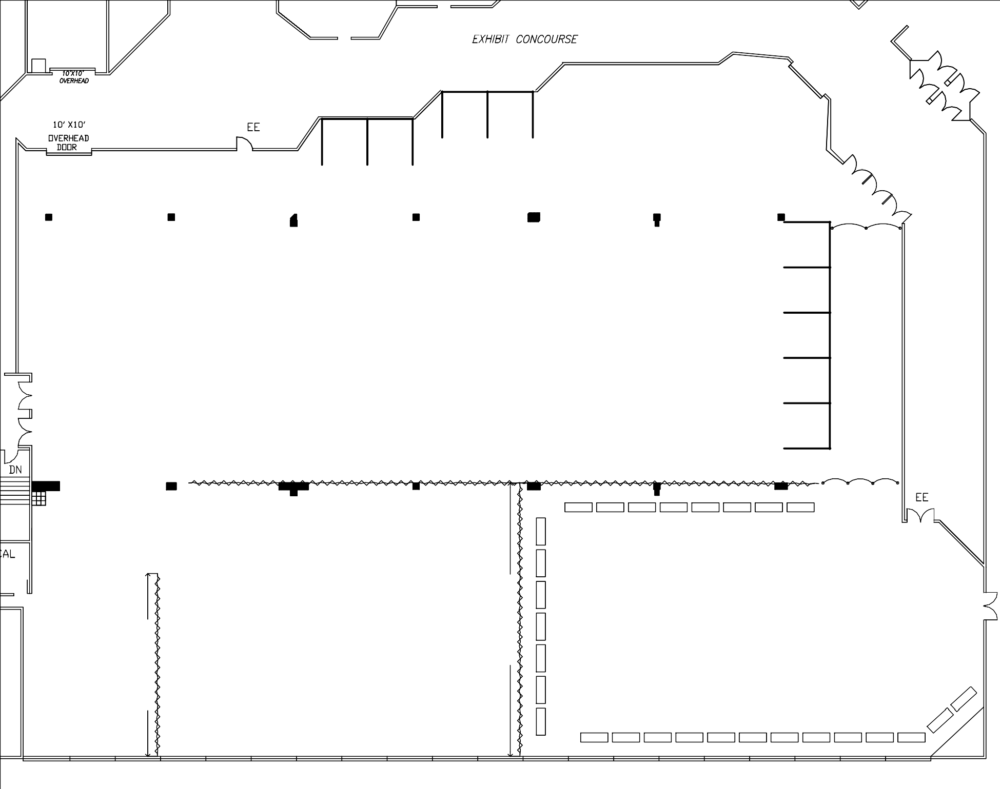

SOCIETY FAIR
SPAUL
SOCIETY FAIR

OVERHEAD DOOR
703 | 702 | 701 | 700

SOCIETY FAIR
705
704

15'-10"

15'-8"
707

12'-6"
500 | 401
502 | 403
504 | 405
506 | 407
508 | 409

600 | 501
601 | 503
603 | 505
605 | 507
607 | 509

400 | 301
402 | 303
404 | 305
406 | 307
408 | 309

706

19'

24'

MAIN ENTRANCE

19'

16'

9' 9' 9' 9' 9'
100

102

104

106

108

Stanchions

16'

73' OF 3'h MASKING
300 |  |  | 201
302 |  |  | 203
304 |  |  | 205
306 |  |  | 207
308 |  |  | 209

200 | 101
202 | 103
204 | 105
206 | 107
208 | 109

7'-10" 7'-10"
65' OF 8'h MASKING

Stanchions

8TT

7TT

6TT

5TT

4TT

3TT

2TT

1TT

Booths shaded in blue are taken.
CASH BAR
15TT 14TT 13TT 12TT 11TT 10TT 9TT

Ancestors Road Show
40'-5" of 8'h Masking
60'-5" of 8'h Masking
Friday & Saturday ^{I}

16TT

17TT

18TT

19TT

20TT

21TT

22TT

23TT

24TT

25TT
1
2

26TT T

(

183'-9"

